
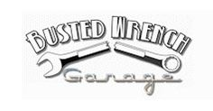


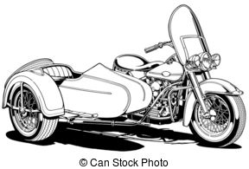

Saturday, June 3, 2017 - 9:00 AM to 5:00 PM
ADMISSION TO ALL EVENTS IS FREE

Silent Auction
Throughout the day
Items donated by dealers & organizations in
South MS

Location

2311 29th Street
Gulfport, MS 39501
Entry fee for participants is $25 for General Public and $20 for USCA Members
Open to ALL 2 & 3 wheeled vehicles // All entering receive free T shirt

Second Annual USCA Mississippi Sidecar Rally/Show
INFO
Mike Bodisch USCA Rep.
601-788-7409
Stacie Hans Busted Wrench
228-864-9082
All Proceeds from the event will go to Joppa Shrine
to support
Shriners Children’s Hospitals

Awards to be given for
Best of Show - This has to be a sidecar rig. Awards for 1st, 2nd and 3rd
Best Monkey - Only one best monkey award
Road Kill – Fastest times. Awards for 1st, 2nd and 3rd
Poker Run – Best hand drawn. Awards for 1st, 2nd and 3rd
Children’s Competition - Best coloring work.

United SideCar Association


